The new Holiday Act

What does the new Holiday Act mean to you?
On September 1st, 2020, a new Holiday Act will be in force. But what will the new provisions mean to you and is there something you should pay special attention to already? We have collected some of the answers for you here.

The Holiday Act today
Presently, you accrue your holiday during the calendar year from January 1st to December 31st – but you cannot use the holiday until the holiday year from May 1st to April 30th the next year. Hence, it may be 16 months from you accrue your holiday and until you can use it. Due to criticism from EU, the Holiday Act is now changed.

From September 2020 we change to ”concurrent holiday”
Concurrent holiday means that you accrue and use the holiday within the same holiday year. The holiday you accrue in September you can use already in October that same year.
Many things continue as you know them today:
- You are still entitled to 5 weeks of holiday yearly.
- You are still entitled to 3 consecutive weeks of main holiday and 2 remaining weeks of holiday.
- You are still entitled to 3 weeks of holiday in the main holiday period from May 1st till September 30th.

Though a lot continues as you know it, the transition to concurrent holiday has required an adjustment of the Holiday Act.

New holiday year: You still accrue 2.08 of paid holiday per month, but in the future, you will accrue the holiday during the period from September 1st till August 31st (12 months), also known as the holiday year. The start of the holiday year is moved from May 1st to September 1st to ensure the holiday pattern most people have today.

The holiday period As a new concept, a so-called ”holiday period” is introduced, running from September 1st till December 31st the following calendar year, that is the holiday year + 4 months (16 months). This means, that the 5 weeks you accrue from September 1st, 2020 till August 31st, 2021 can be taken until December 31st, 2021.

As the graph below shows, the holiday year and the holiday period overlaps. This means you can use your ”old holiday” during the holiday period, ending December 31st , even though a new holiday year starts on September 1st.
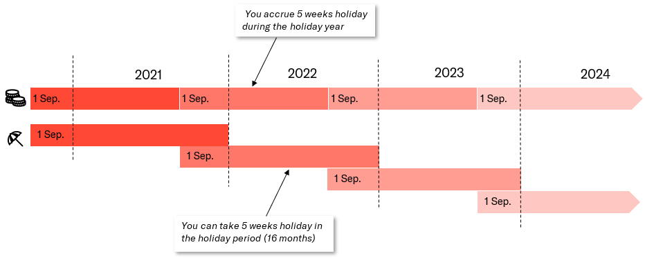
The prolonged holiday period allows for planning flexibility as you will no longer have a balance of 25 holidays at the beginning of the holiday year the way you are used to.
Below are 2 examples of how you can spend your holiday. Please note, the holiday must be accrued prior to using it.

Example 1:
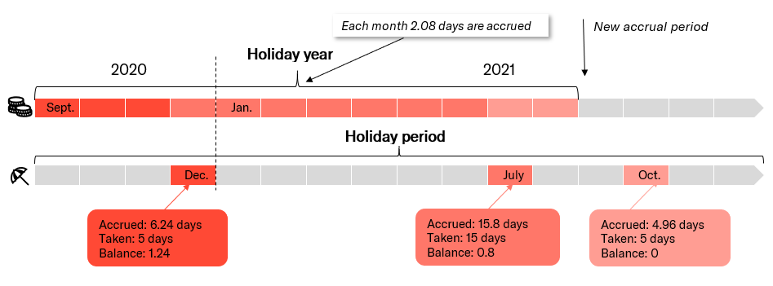

Example 2:
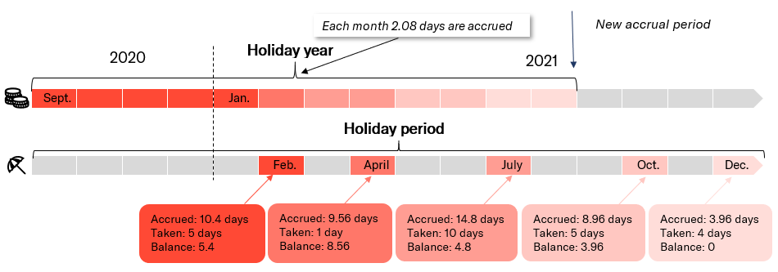
Special rules apply if you are a trainee, depending on when your trainee period has started. Contact your employer for further information on holiday for trainees.

Payment during holiday
When using your holiday according to the new Holiday Act, you will still get either:
- Holiday with pay + 1 percent holiday benefit or
- 12.5 percent holiday allowance.

Special transition to concurrent holiday
When changing from staggered accrual and using of holiday to concurrent holiday, a surplus holiday will occur. According to the rules today, the surplus holiday will not be payable until you retire.
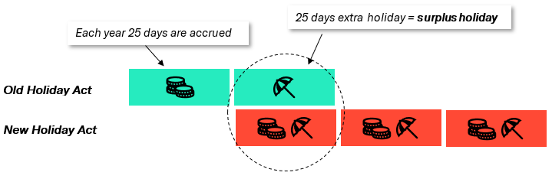

A special transition arrangement has been made to ensure that your surplus holiday is still payable when you retire. The transition arrangement means that the 5 weeks of holiday you accrue from September 1st, 2019 to August 31st, 2020, is ”frozen” in a special fund – The Salary Earners Fund for Outstanding Holiday means. The fund freezes the surplus holiday and ensures that interest is credited until the day you reach your age of retirement.

It is not possible for your employer to pay the surplus holiday directly to you. Only the fund can pay you the surplus holiday with interest when you are entitled to receive it - hence, when you retire. If you leave the Danish labour market before your age of retirement, you may in certain situations apply the fund for earlier payment.
The transition arrangement also ensures that the beginning of the holiday year is moved from May 1st to September 1st, 2020.
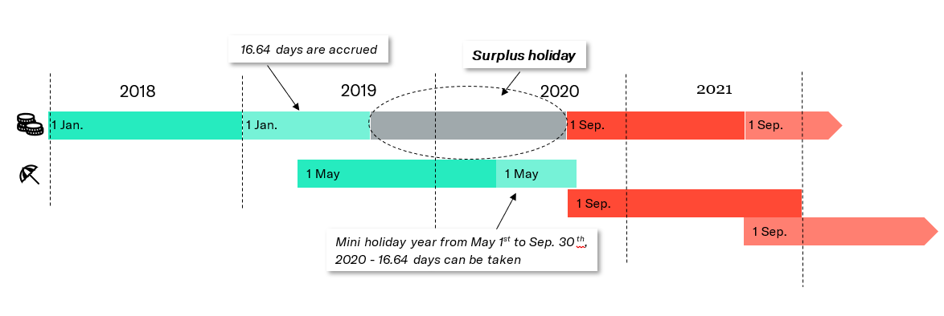

What to be aware of now!

Summer holiday 2020 – ”mini holiday year”
From January 1st till August 31st, 2019, you accrue 16.64 holidays if you are employed for the entire period. These days you can use for your summer holiday in the mini holiday year, running from May 1st till September 30th, 2020. See illustration above.
Should you wish to use more than 16.64 days during that period, you may transfer days from the holiday year, ending on April 30th, 2020. The transfer must be approved by your employer.
If you do not spend all 16.64 days in the mini holiday year, the remaining days are transferred automatically to be spend prior to December 31st, 2021.

Autumn break 2020
The new holiday year commences on September 1st, 2020 and on this day, you start out with 0 holidays. At the end of September 2020, you have accrued 2.08 holidays. This means that you will not have enough days for a week’s autumn break in October 2020.
Should you wish to have a week’s autumn break in October 2020, you can save some of the days from the mini holiday year or transfer days from the holiday year ending on April 30th, 2020.

What happens to your 5 additional holidays/the 6th week of holiday?
If you are entitled to additional holidays or a 6th week of holiday, the right follows a collective agreement, your employment contract, or the employment handbook of the company. Additional holidays are not regulated by the Holiday Act. Hence, your right to additional holidays/6th week continues undisturbed, unless the regulations of the collective agreement, or your employment contract/employment handbook change.

What changes on September 1st, 2020?
On September 1st, 2020 a number of new regulations take effect. See below for some of the most important changes.

New regulations on payment of holiday allowance
If you have paid holiday, you are presently entitled to a payment of 1 percent of the salary of the accrual year as holiday benefit, i.e. the calendar year prior to the holiday year.
You are also entitled to 1 percent holiday benefit according to the new Holiday Act, but the time of payment is changed. Your employer may choose to pay the holiday benefit proportionally when the holiday is taken, or at two fixed payment dates in May and August.
- Holiday benefit for the period of September 1st to May 31st is payable with the May salary (9/12)
- Holiday benefit for the period of June 1st to August 31st is payable with the August salary (3/12)

The below table shows when and how much you will receive as holiday allowance during the transition period if the allowance is paid in one instalment:
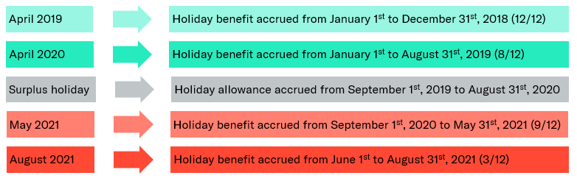

Payment of 5th holiday week
If you do not use your 5th week of holiday prior to the expiry of the holiday period on December 31st, your employer will automatically pay you its value, unless you have agreed to transfer that week to the next holiday period by December 31st.

Holiday in advance
According to the new Holiday Act, you may on certain terms use your holiday “in advance”. These regulations offer an opportunity to use your holiday even though you have not yet accrued it. Holiday in advance require a specific agreement with your employer. The agreement can be made for the present holiday year and may not include more holiday than what may be accrued in that year. If you terminate your position before the advanced holiday has been accrued, your employer may set the value off against your salary and holiday allowance owing.

Illness, maternity leave, and other holiday hindrances
If you cannot use your holiday due to illness or maternity leave, the holiday will automatically be transferred to the next holiday period in the future. It will no longer be possible to pay-out the value of holiday due to any hindrance. However, this does not apply to the 5th week of holiday which is automatically paid if you have not made an agreement to transfer it, see above.

Notes

